**FUNDAMENTALS OF SOFTWARE ENGINEERING**

**(CS-2004)**

**Project Name: BookStore Management System**

**Team Name:** **Infinity Coders**

**Group Members:**

* **Sarita Sangrez (23i-2088)**
* **Syeda Shanzay Shah (23i-2016)**
* **Laiba Nasir (23i-2079)**

**Deliverable Number: 3**

**Date of Submission: 3rd May 2025**

**Project Title: LexiShop-BookStore Management System**

1. **Introduction:**

The Book Management System is designed to provide users with a seamless and efficient way to search for and read books online. This system addresses the challenge of finding books across different categories by offering an intuitive search functionality based on genre, author, and title.

The platform supports both guest and registered users, with purchasing privileges restricted to registered users. To enhance user experience, the catalogue is well-organized for easy browsing and integrates a secure payment system to ensure safe transactions.

The scope of this project includes book listing, searching for books, placing orders, and managing inventory. However, it does not support book rentals or integration with physical bookstores. By providing a user-friendly interface and a secure transaction process, the system aims to cater to book enthusiasts, making book discovery and purchasing effortless.

1. **User Stories:**

|  |  |  |  |  |
| --- | --- | --- | --- | --- |
| |  | | --- | | **IMPORTANCE:**  ***5*** |   **STORY ID**: *US-01* **STORY TITLE**: ***View Bookstore Homepage***     **USER STORY**:   |  | | --- | | **As a**: User  **I want:** to view the bookstore homepage.  **so that:** I can browse available books and navigate the site easily. |  |  | | --- | | **ESTIMATE:**  ***3*** |      |  | | --- | | * And I know I am done when I can see a homepage displaying book categories and featured books. * And I know I am done when I can navigate to different sections of the site from the homepage. |   **ACCPETANCE CRITERIA TYPE:**   ***Search***   ***View*** |

USER STORY: 01

USER STORY: 02

|  |  |  |  |  |
| --- | --- | --- | --- | --- |
| **STORY ID**: *US-02* **STORY TITLE**: ***Admin Login***    **USER STORY**:   |  | | --- | | **As a**: Admin  **I want:** I want to log into the system. **so that:** I can manage books. |  |  | | --- | | **IMPORTANCE:**  ***5*** |  |  | | --- | | **ESTIMATE:**  ***4*** |      |  | | --- | | And I know I am done when I can enter my admin credentials and access the admin dashboard.  And I know I am done when unauthorized users cannot log into the admin panel. |   **ACCPETANCE CRITERIA TYPE:**   ***Workflow***   ***Manage Data*** |

USER STORY: 03

|  |  |  |  |  |
| --- | --- | --- | --- | --- |
| **STORY ID**: *US-03*  **STORY TITLE**: **Admin Can Add Books**    **USER STORY**:   |  | | --- | | **As a**: Admin  **I want:** to add books to the bookstore.  **so that:** users can see and purchase them. |  |  | | --- | | **IMPORTANCE:**  **4** |  |  | | --- | | **ESTIMATE:**  **5** |      |  | | --- | | * And I know I am done when I can input book details (title, author, price, category) and save them in the system. * And I know I am done when users can view newly added books in the bookstore. |   **ACCPETANCE CRITERIA TYPE:**   ***Manage Data***   **Report/View** |

USER STORY : 04

|  |  |  |  |  |
| --- | --- | --- | --- | --- |
| |  | | --- | | **IMPORTANCE: *4*** |   **STORY ID**: *US-04* **STORY TITLE**: ***Search for Books***    **USER STORY**:   |  | | --- | | **As a**: Admin  **I want:** to search for books by title, author, or category. **so that:** I can easily find what I’m looking for. |  |  | | --- | | **ESTIMATE:**  ***3*** |      |  | | --- | | * And I know I am done when I can enter a search term and see relevant book results. * And I know I am done when search filters help refine my results. |   **ACCPETANCE CRITERIA TYPE:**   ***Search***   ***Workflow*** |

|  |  |  |  |  |
| --- | --- | --- | --- | --- |
| **STORY ID**: *US-05* **STORY TITLE**: ***Order Placement***    **USER STORY**:   |  | | --- | | **As a**: User  **I want**: to place an order for books.  **so that**: I can purchase books from the bookstore. |  |  | | --- | | **IMPORTANCE: *5*** |  |  | | --- | | **ESTIMATE:**  ***4*** |      |  | | --- | | And I know I am done when I can select books and successfully place an order.  • And I know I am done when I receive a confirmation message after placing an order. |   **ACCPETANCE CRITERIA TYPE:**   **Workflow** |

USER STORY : 05

|  |  |  |  |  |
| --- | --- | --- | --- | --- |
| **STORY ID**: *US-06* **STORY TITLE**: ***ADD TO CART***    **USER STORY**:   |  | | --- | | **As a**: User  **I want:** to add books to a shopping cart.  **so that:** I can purchase multiple books together easily. |  |  | | --- | | **IMPORTANCE:**  ***5*** |  |  | | --- | | **ESTIMATE:**  ***5*** |      |  | | --- | | • And I know I am done when I can select a book and add it to my shopping cart. • And I know I am done when I can view the items currently in my cart. • And I know I am done when the cart updates correctly when I add multiple items. |   **ACCPETANCE CRITERIA TYPE:**  Workflow |

USER STORY : 06

USER STORY : 07

|  |  |  |  |  |
| --- | --- | --- | --- | --- |
| **STORY ID**: *US-07* **STORY TITLE**: ***Update Book Details***    **USER STORY**:   |  | | --- | | **As a**: Admin  **I want:** update book information like title, author, price, and stock.  **so that**: the bookstore always shows correct and updated details. |  |  | | --- | | **IMPORTANCE: 5** |  |  | | --- | | **ESTIMATE:**  ***4*** |      |  | | --- | | • And I know I am done when I can edit and save updated book details successfully.  • And I know I am done when I receive a confirmation after updating book information. |   **ACCPETANCE CRITERIA TYPE:**  Manage Data |

USER STORY : 08

|  |  |  |  |  |
| --- | --- | --- | --- | --- |
| **STORY ID**: *US-06* **STORY TITLE**: ***Wishlist***    **USER STORY**:   |  | | --- | | **As a**: User  **I want**: to add books to my Wishlist.  **so that**: I can save them for future purchase. |  |  | | --- | | **IMPORTANCE: 5** |  |  | | --- | | **ESTIMATE:**  ***4*** |      |  | | --- | | • And I know I am done when I can successfully add and view books in my Wishlist.  • And I know I am done when I can remove books from my Wishlist if I change my mind. |   **ACCPETANCE CRITERIA TYPE:**  Workflow |

USER STORY : 09

|  |  |  |  |  |
| --- | --- | --- | --- | --- |
| **STORY ID**: *US-09*  **STORY TITLE**: ***View Users***    **USER STORY**:   |  | | --- | | **As a**: Admin  **I want:** I want to view the list of registered users.  **so that**: I can manage and monitor user activities. |  |  | | --- | | **IMPORTANCE: 5** |  |  | | --- | | **ESTIMATE:**  ***4*** |      |  | | --- | | • And I know I am done when I can successfully see a list of all users with their details.  • And I know I am done when I can search for a specific user in the list. |   **ACCPETANCE CRITERIA TYPE:**  Manage Data |

USER STORY : 10

|  |  |  |  |  |
| --- | --- | --- | --- | --- |
| **STORY ID**: *US-10* **STORY TITLE**: ***Payment***    **USER STORY**:   |  | | --- | | **As a**: Admin  **I want:** to make a payment for my order**.**  **so that:** I can complete my purchase at the bookstore**.** |  |  | | --- | | **IMPORTANCE:**  ***5*** |  |  | | --- | | **ESTIMATE:**  ***4*** |      |  | | --- | | • And I know I am done when I can enter payment details and successfully make a payment.  • And I know I am done when I receive a confirmation message after the payment is processed. |   **ACCPETANCE CRITERIA TYPE:**   ***Workflow*** |

1. **Design**
2. **Class Diagram**

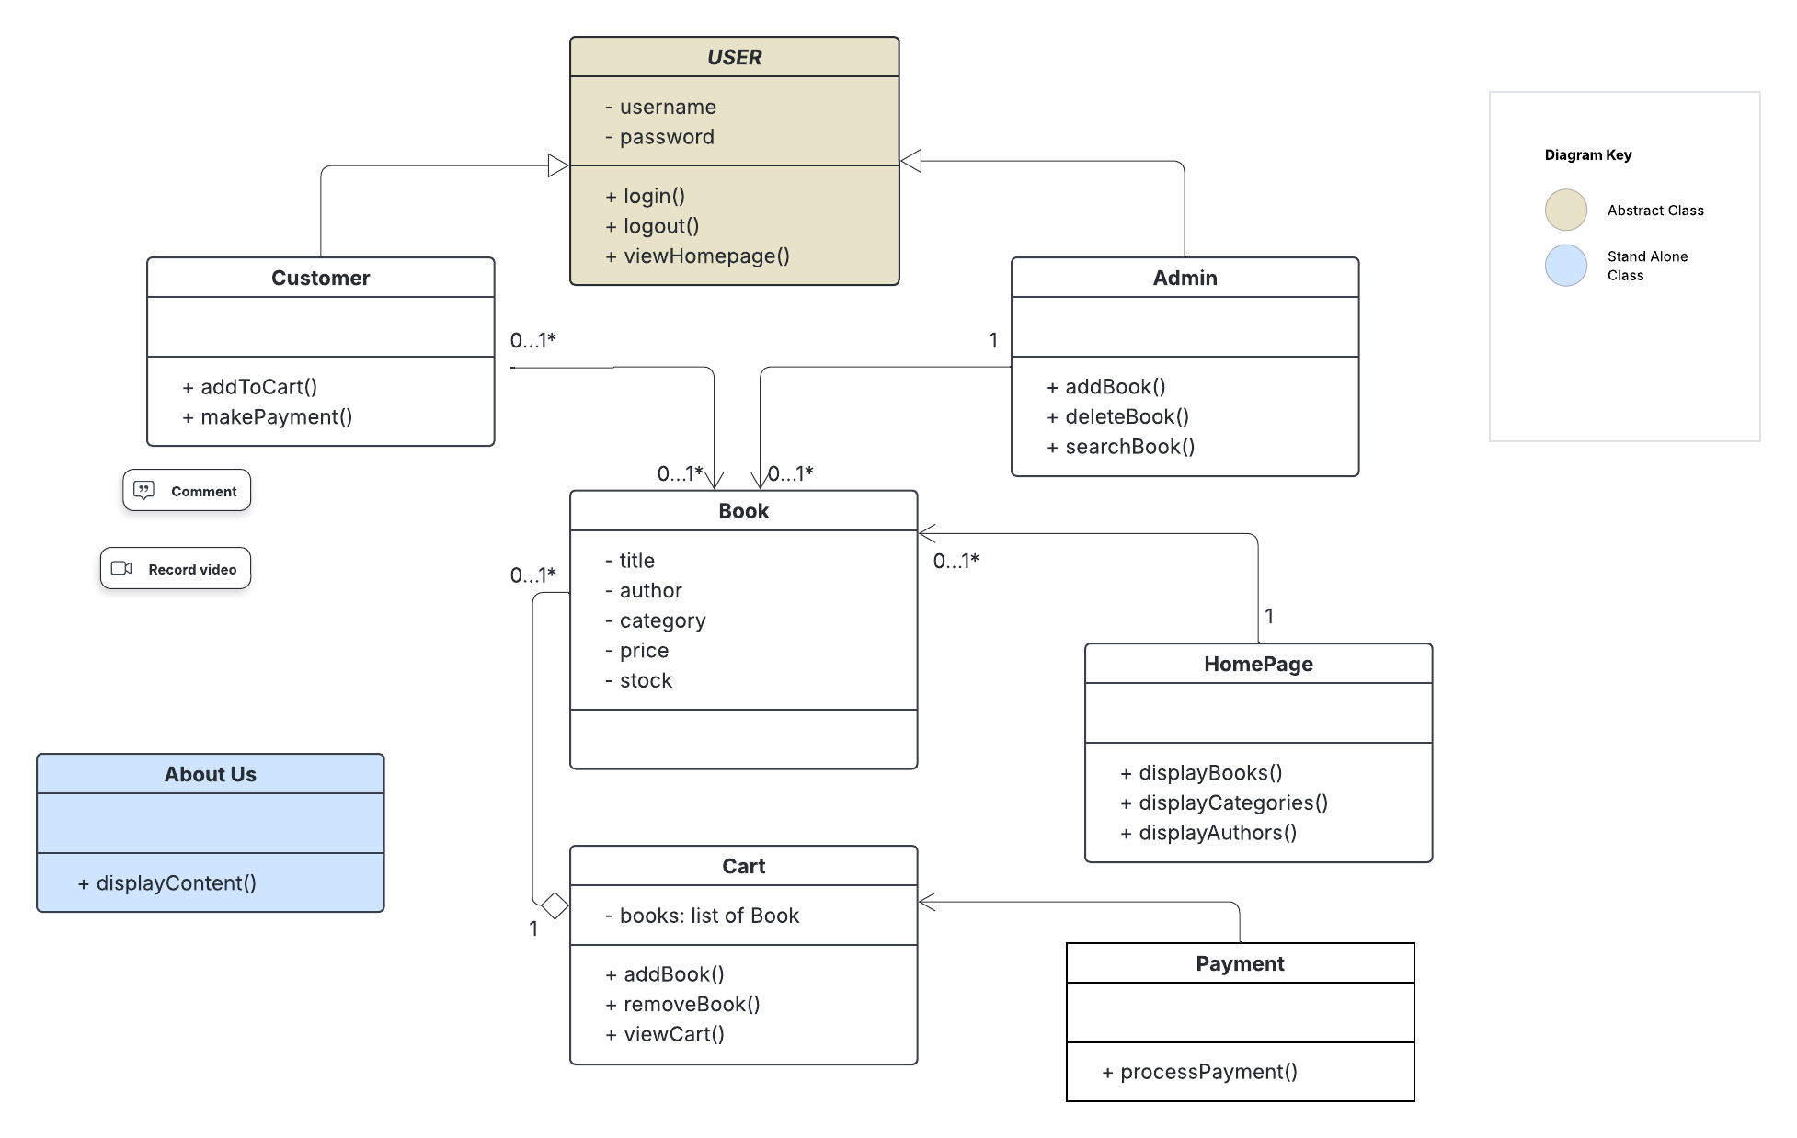

1. **Three Sequence Diagrams**

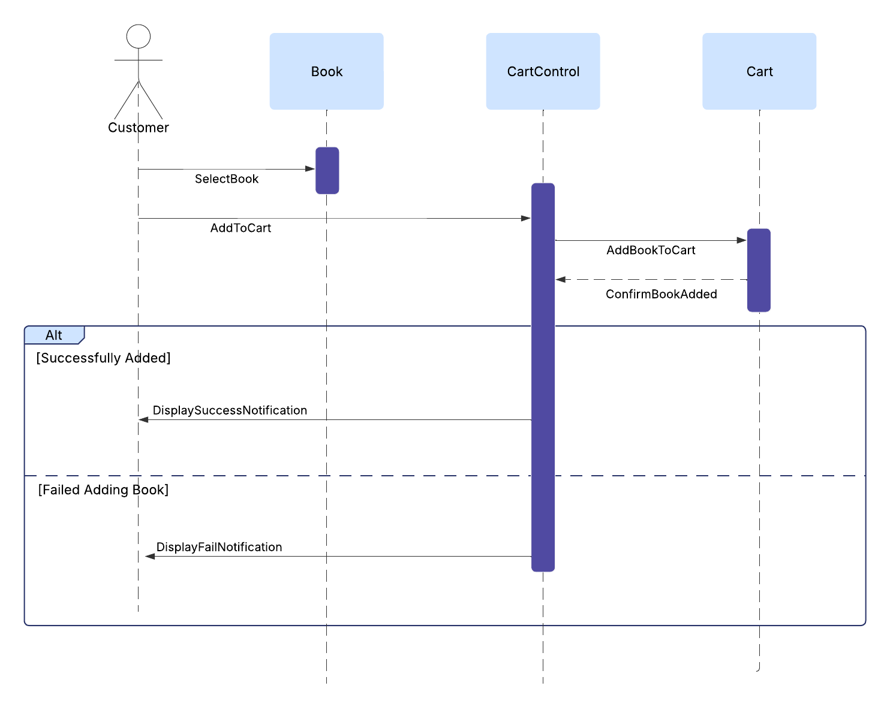

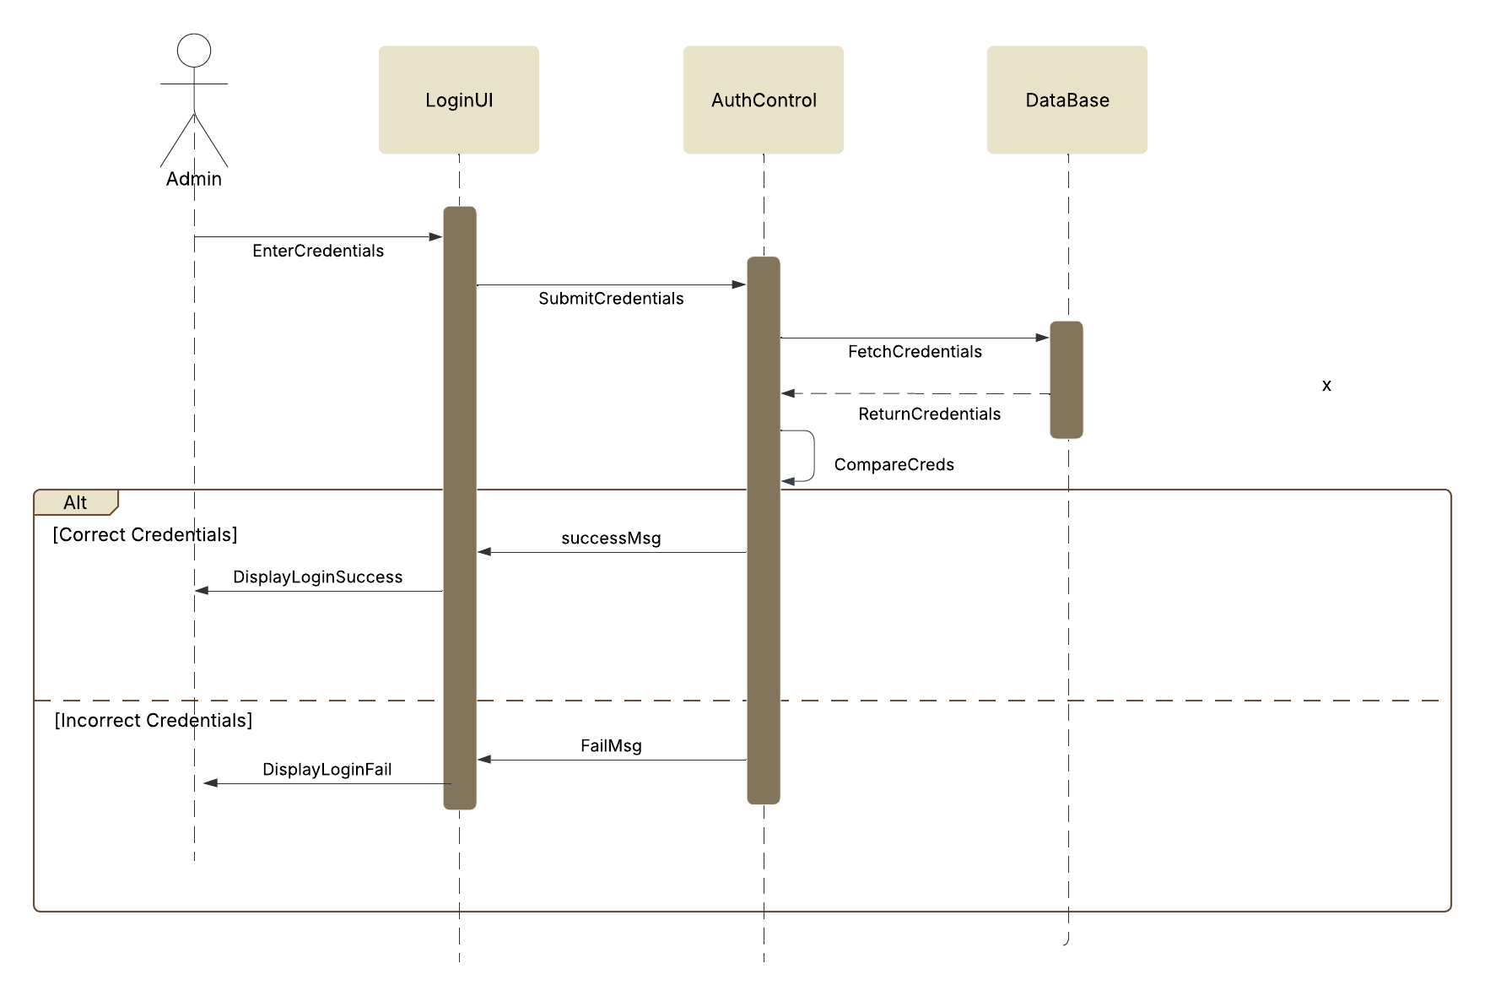

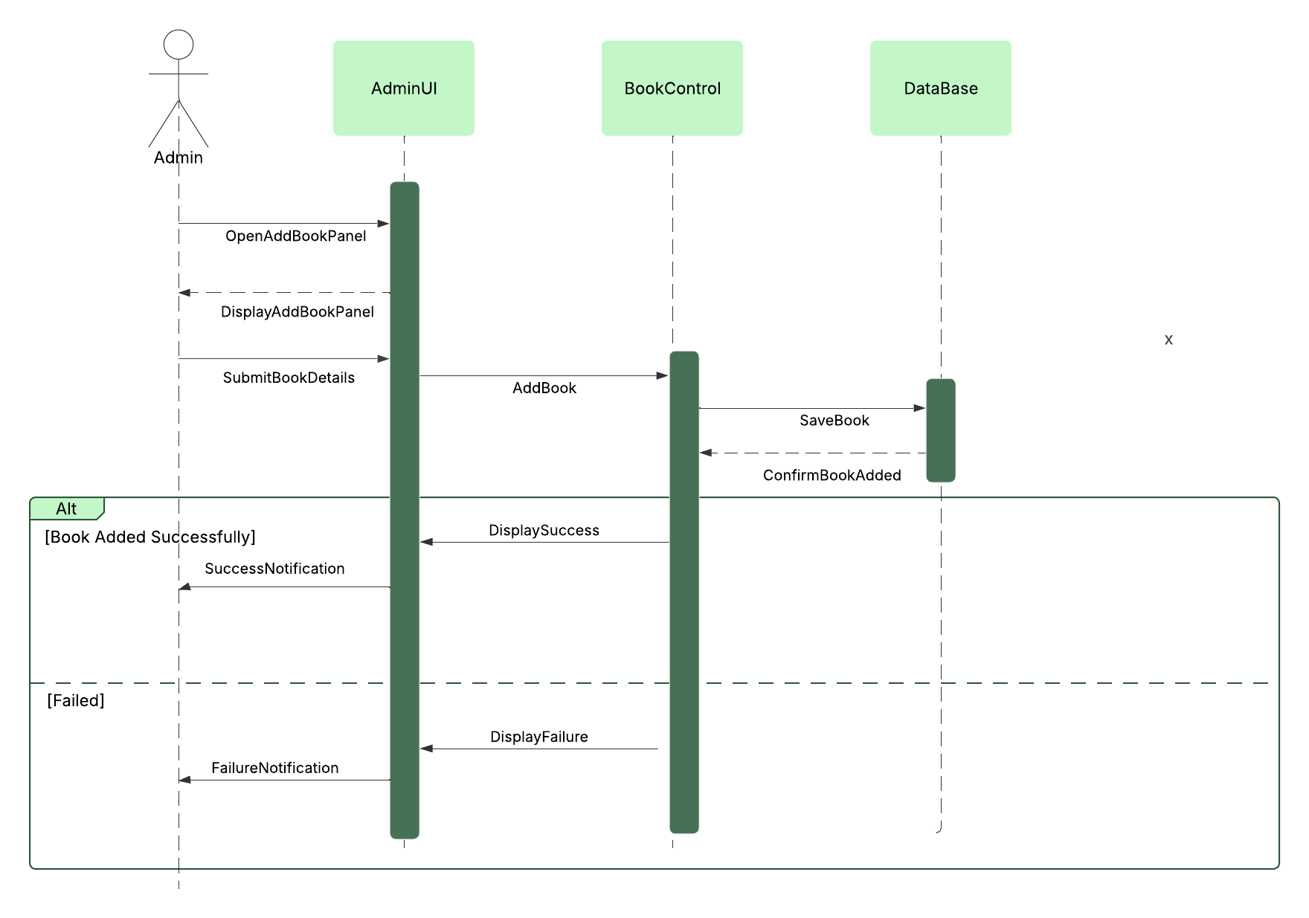

1. **Use Case Diagram**

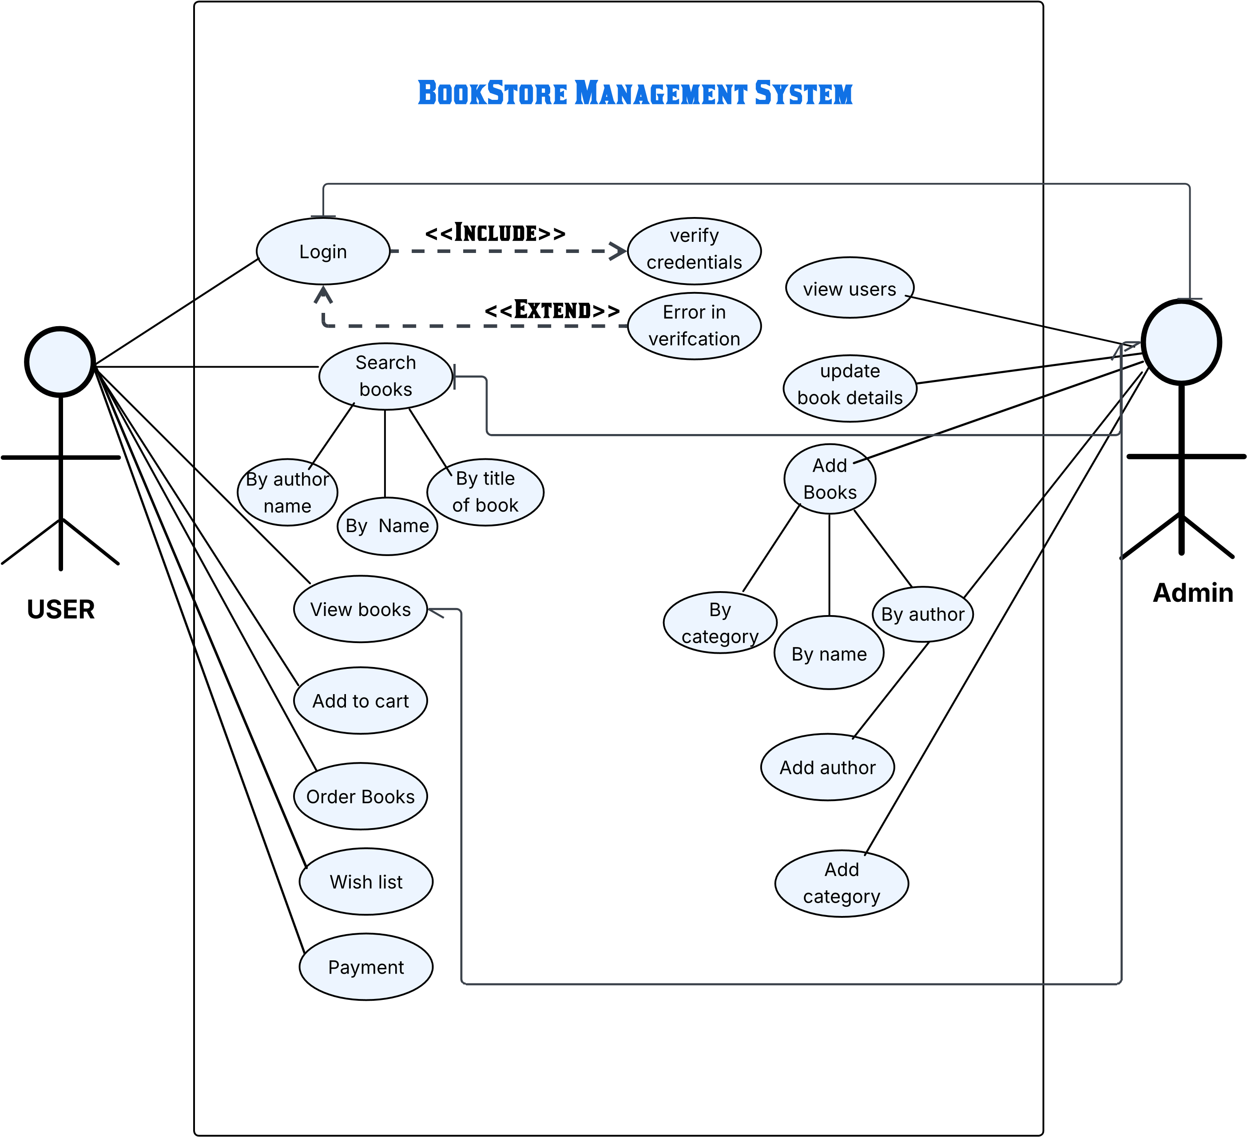

1. **Three Acitvity Diagrams**

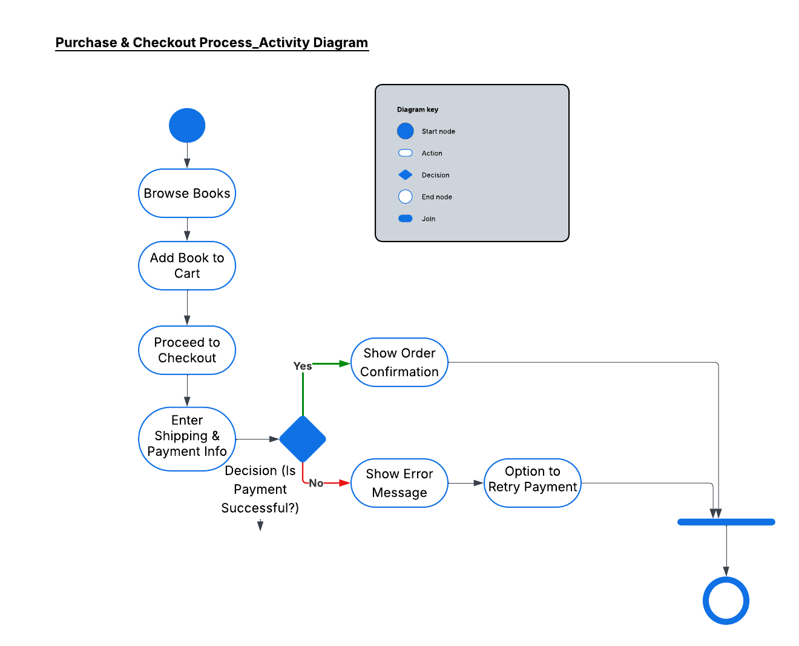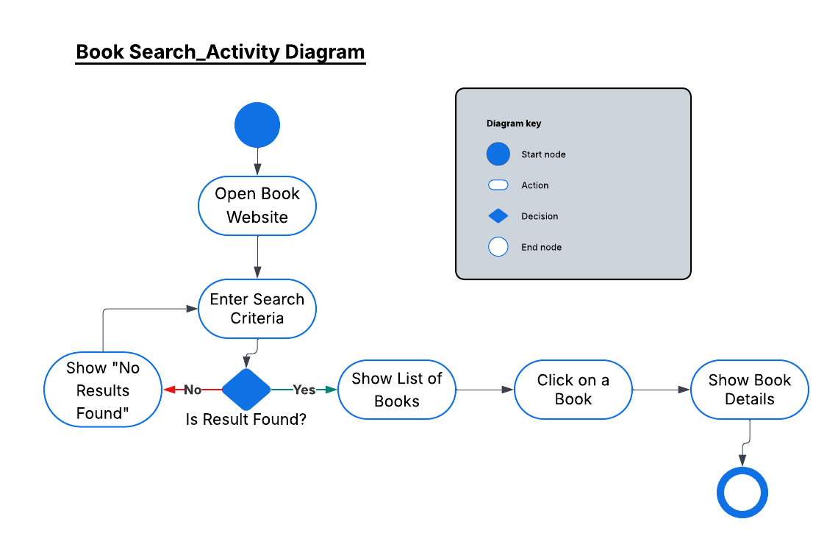

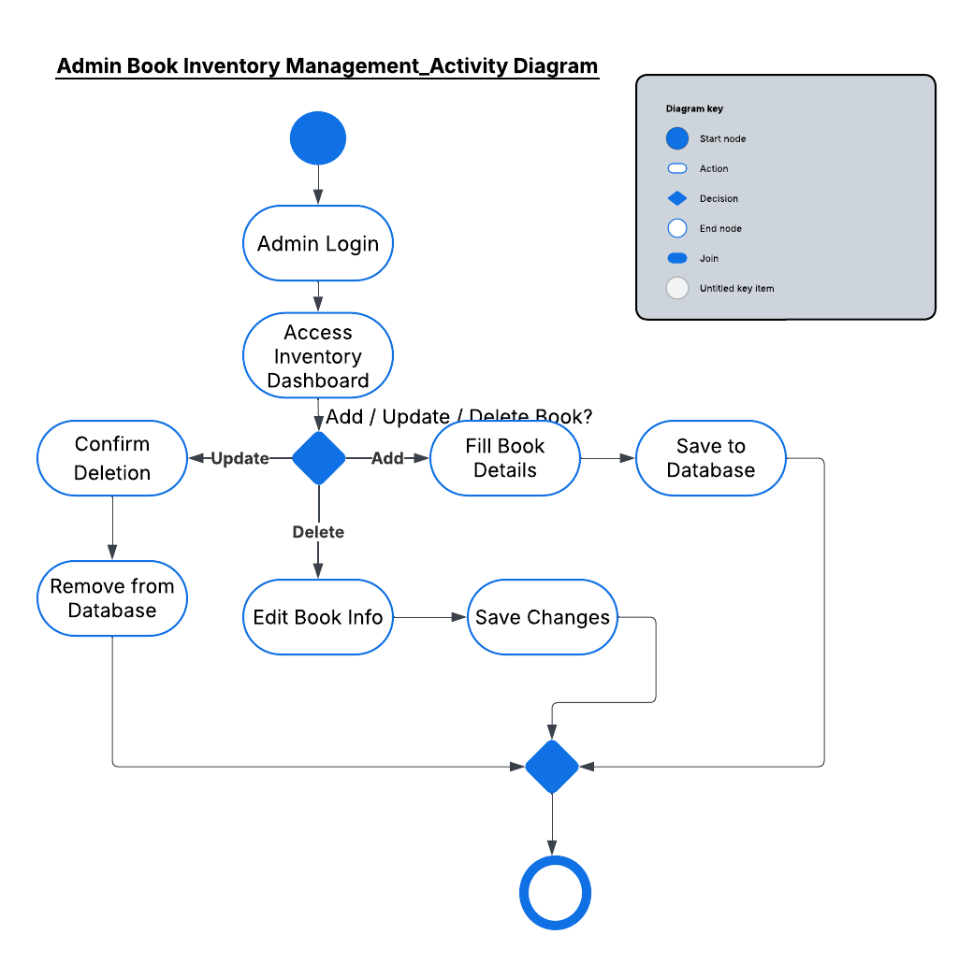

1. **Architecture**

For the Bookstore Management Application, Client-Server Architecture is the most suitable choice. This model enables a clear separation between the user/admin interfaces (clients), the server-side logic, and the centralized database. Clients (both users and admins) interact with the server via requests—users can browse books, search by name or author, manage their cart and wishlist, and place orders, while admins can manage books, authors, and categories. The server processes these requests, applies business rules, and interacts with a database that stores users, books, categories, authors, orders, and payments. This architecture ensures maintainability, scalability, and secure access control, making it ideal for a structured and growing bookstore system.

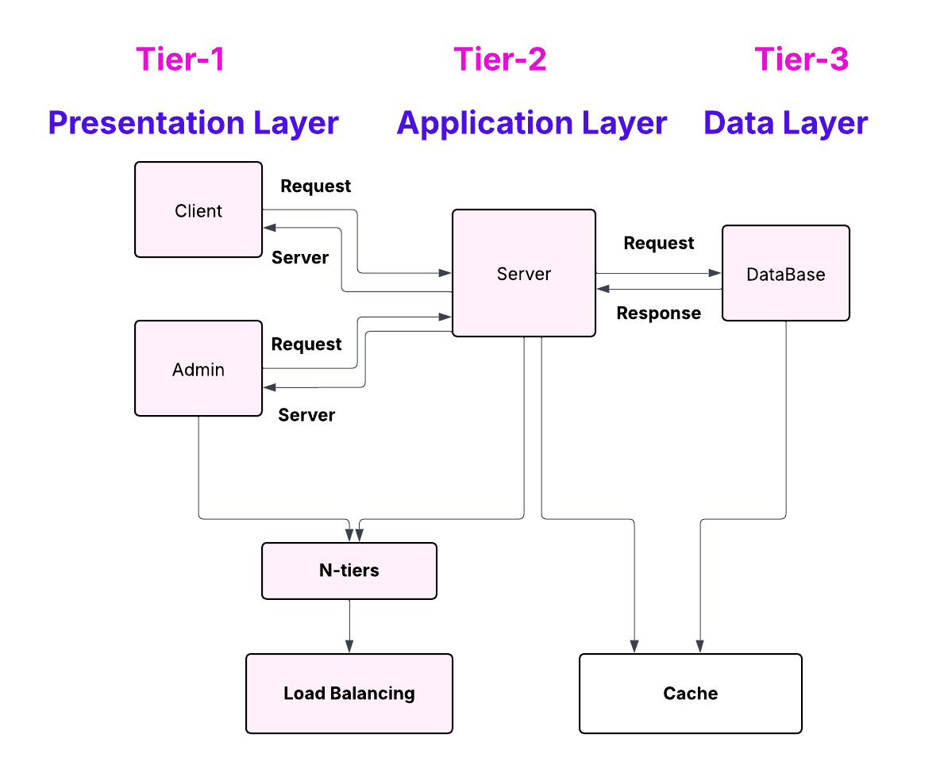

1. **Iteration 1 Implementation screen shots:**
2. **Home Page:**

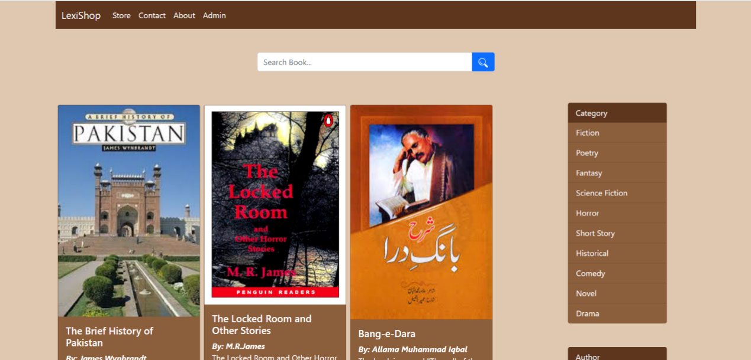

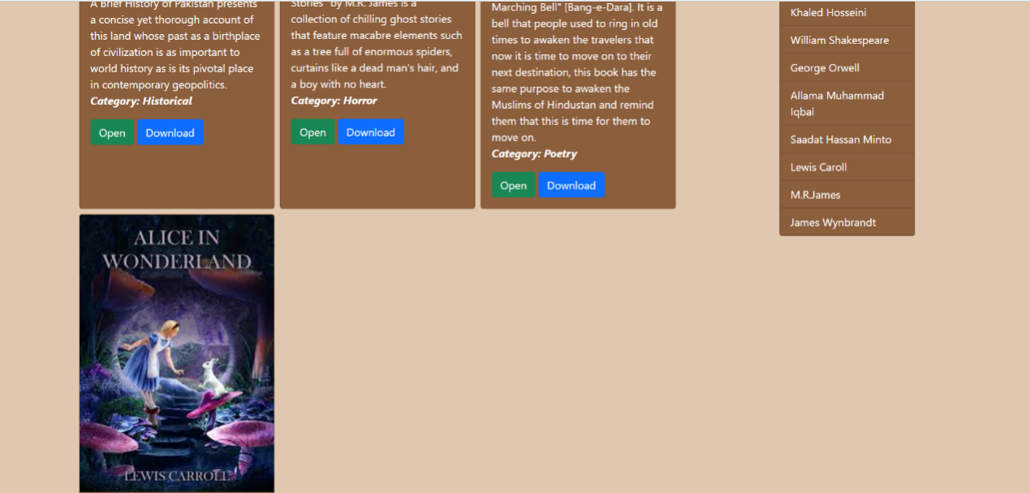

1. **Login Page for Admin:**

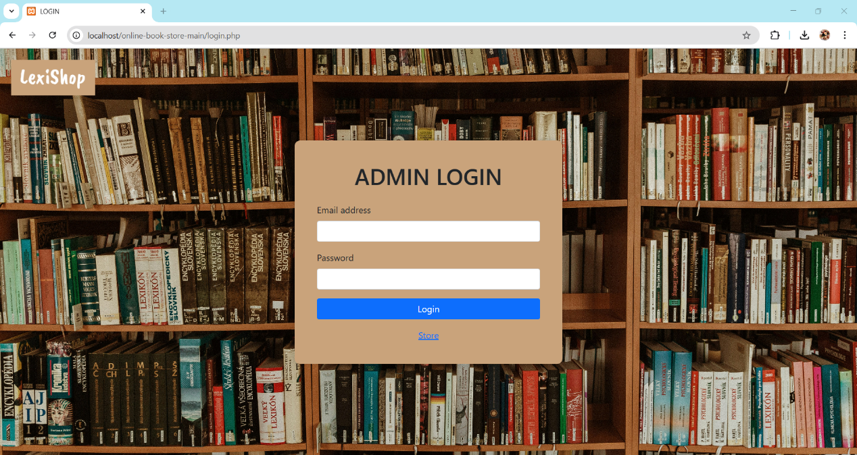

1. **Admin Panel:**

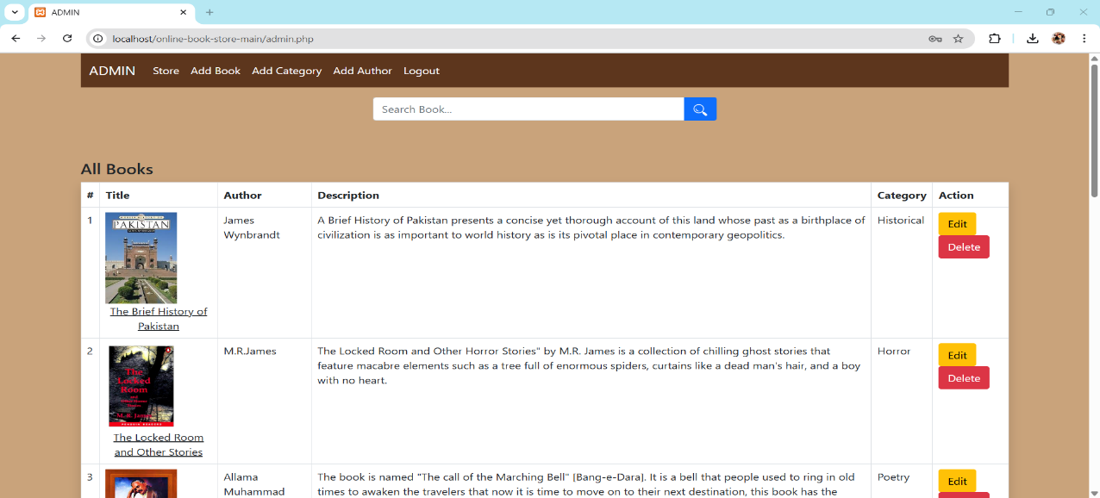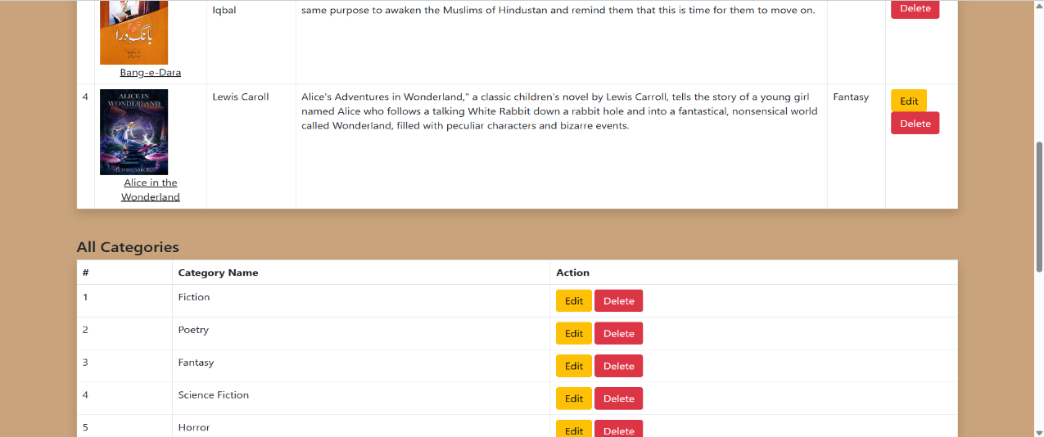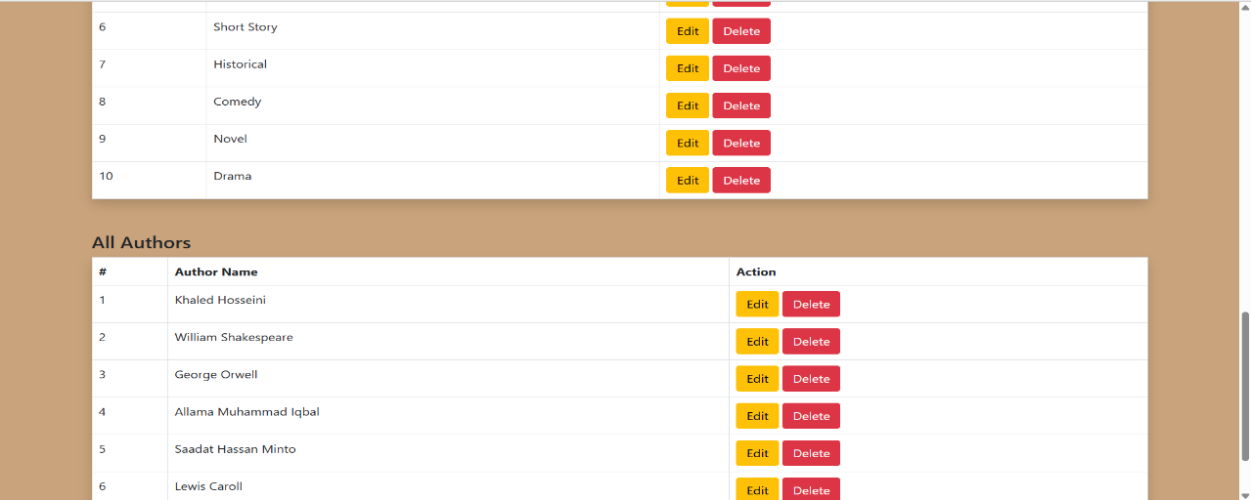

1. **Adding Book Feature:**

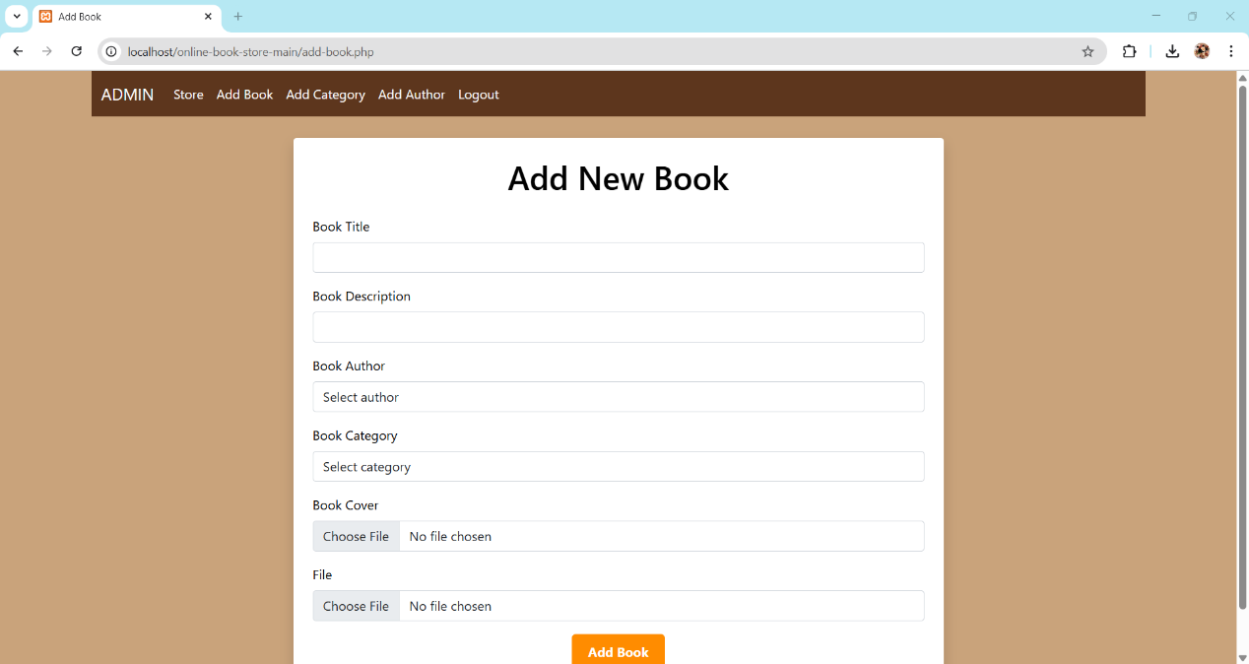

There are error/successful messages as well once the addition is success or failure. Additionally, admin can edit/delete a book as well from database.

1. **Adding Author Feature:**

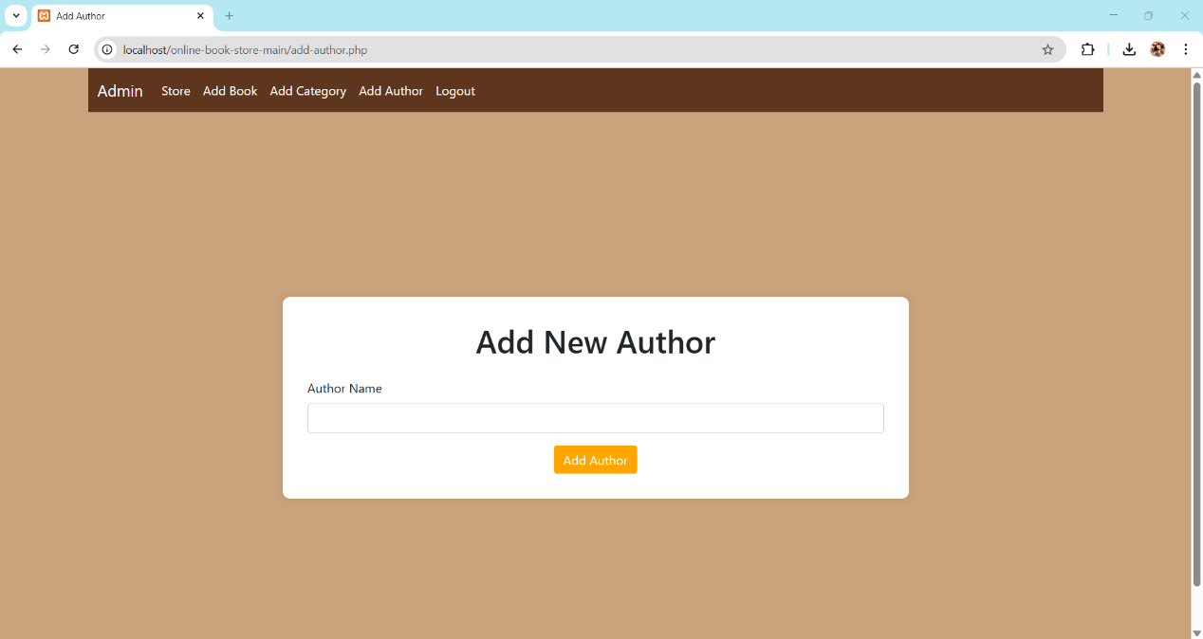

There are error/successful messages as well once the addition is success or failure. Additionally, admin can edit/delete an author name as well from database.

1. **Adding Category/Genre Feature:**

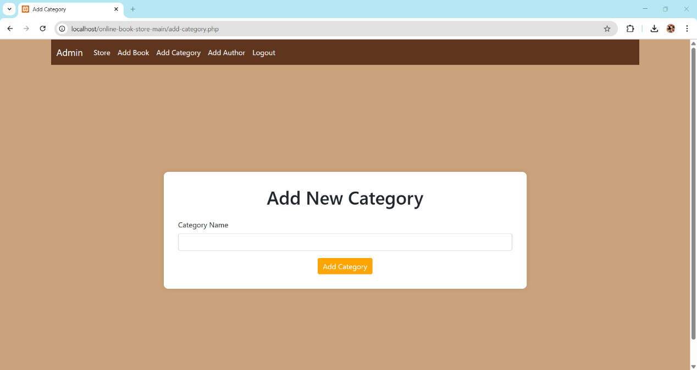

There are error/successful messages as well once the addition is success or failure. Additionally, admin can edit/delete category as well from database.

1. **Burn Down Chart**

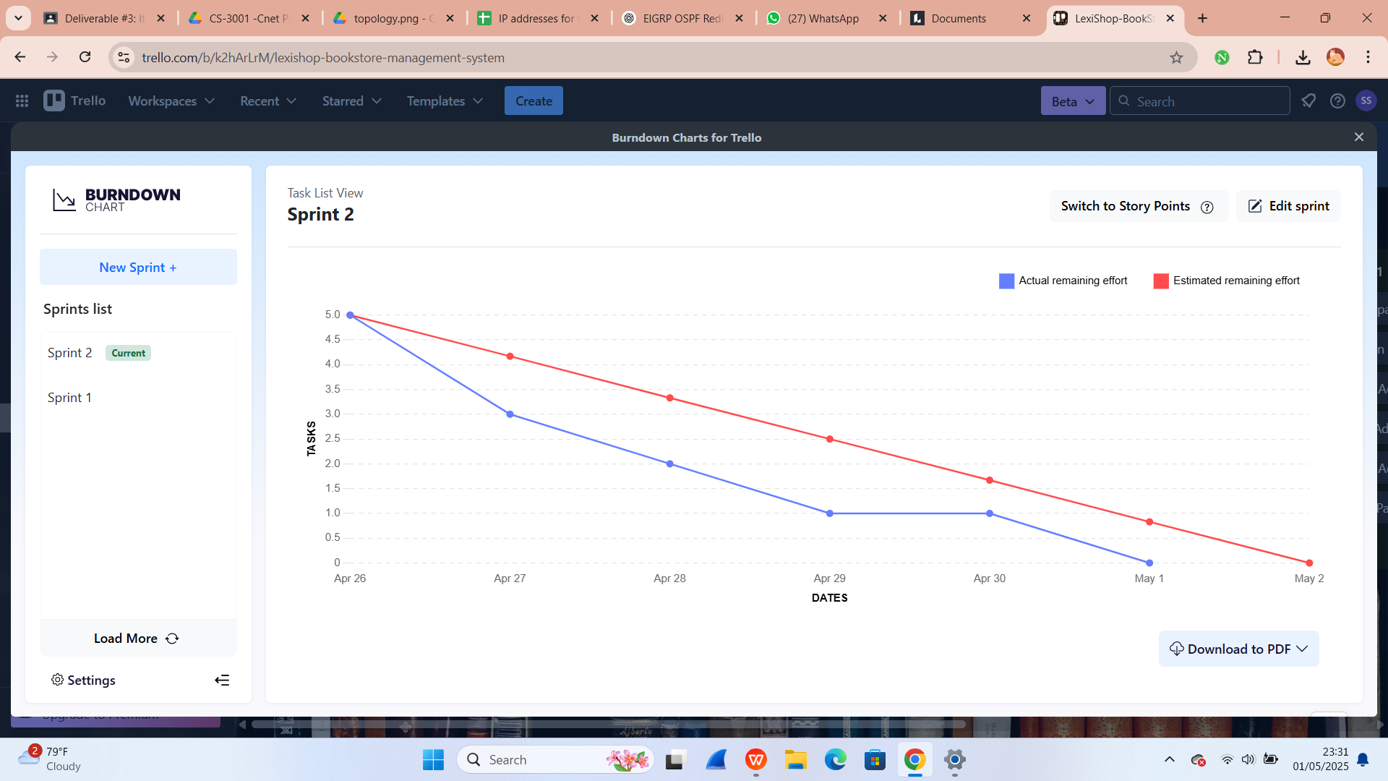

1. **Trello Board**
2. **At the start**

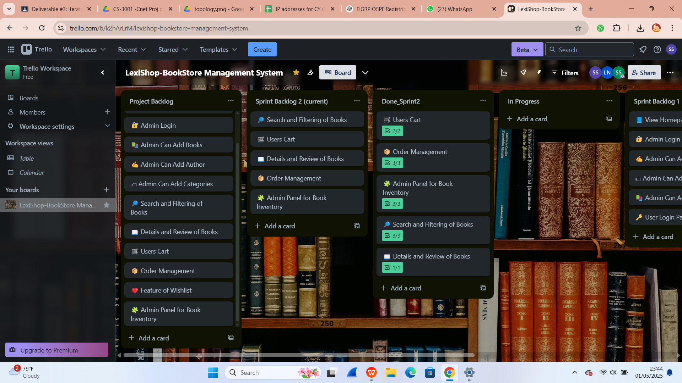

1. **In the middle (50%)**

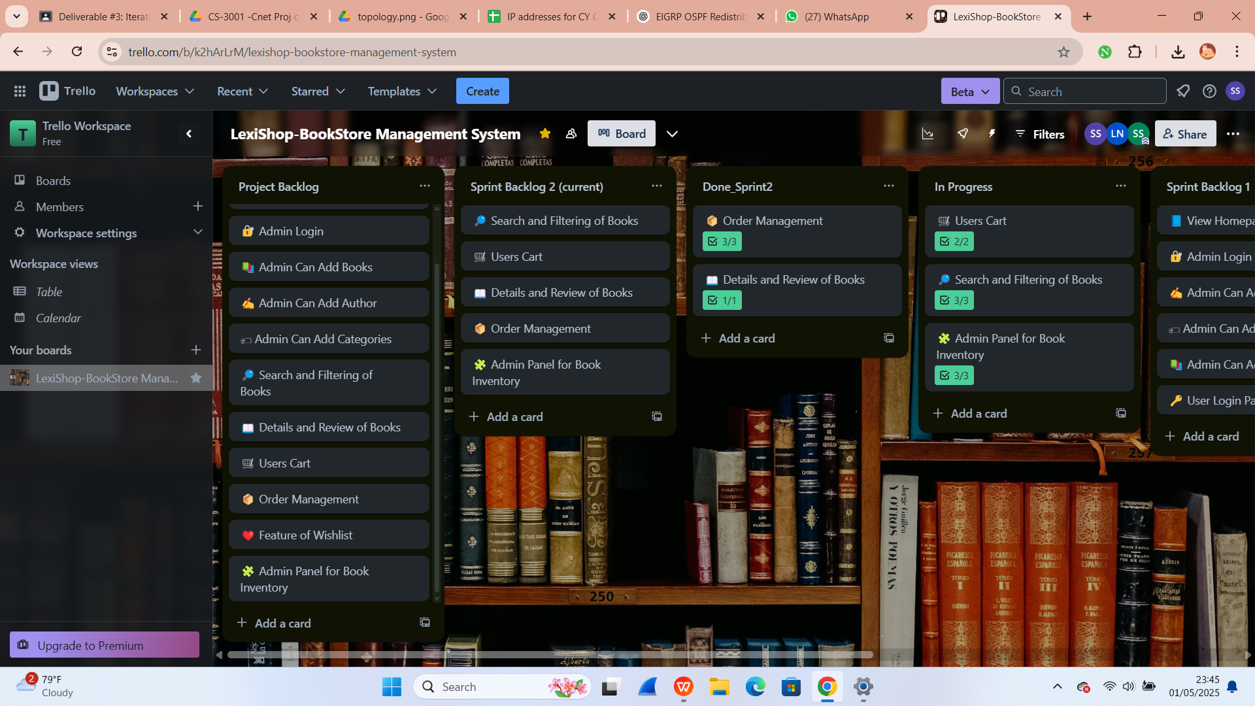

1. **At the end (completed)**

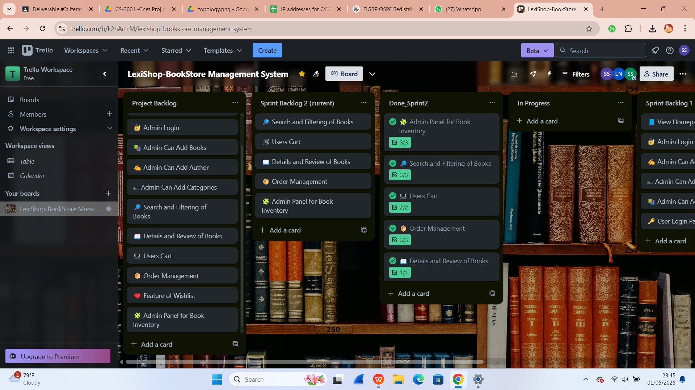

1. **Test Cases**
2. **Work division:**

|  |  |  |
| --- | --- | --- |
| **Team Members** | **Roles/Responsibilities** | **Tasks** |
| **Shanzay** | Backend Developer | * Manage Trello board * Implement AddToCart and Checkout functionalities * Design Activity Diagrams |
| **Laiba** | Tester & Documentation Manager | * Prepare documentation * Take screenshots for Sprint 2 progress * Implement all user stories * Design Architecture Diagram |
| **Sarita** | Frontend Developer | * Design Class Diagram * Design Sequence Diagrams * Style pages (HTML/CSS) for responsiveness |

1. **Lessons Learnt by Group**